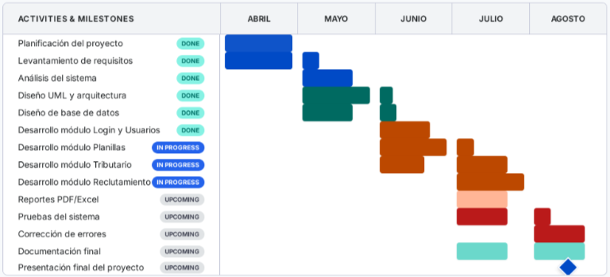
Diagrama de Gantt (Gantt chart)

